CGRA 350 Assignment 3 – Jackson Tume

300446258

# **Part 1:** Key-Frame animation

*Core:*

Brief introduction:

I first create 5 control points at 5 arbitrary locations to give a nice and interesting spline. Then increasing my t value by 0.01 every iteration, I calculate the catmull-rom spline location for the t value. Then put all those spline points into a mesh and have the teapots location follow those spline points calculated. Then using the lookAt function it’s trivial to have the camera follow an object.

How to run:

The program will automatically be running the comp.

*Completion:*

Brief introduction:

I first go through every catmull-rom spline point location and find the distance between the current point and the next point in the array. Using that distance I take the next index distance from the current index distance and that gives me a value, ‘s’. I then multiply that ‘s’ value against the next index – the current index and then add the current index. That maths gives me the new t value, which I plug back into my catmull-rom function to get the new spline location for the second mesh.

How to run:

To display the other teapot that shows the constant speed, just check the imGUI checkbox “show comp”.

*Challenge: *Not Attempted\**

**\*High resolution photos of results are included with submission\***

# **Results:**

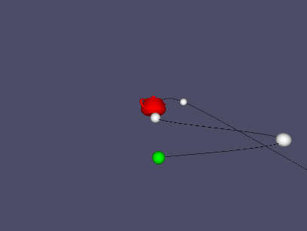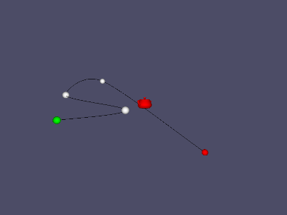

Core

Core zoomed in

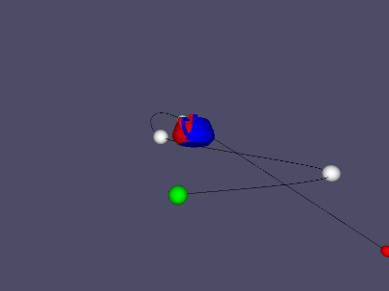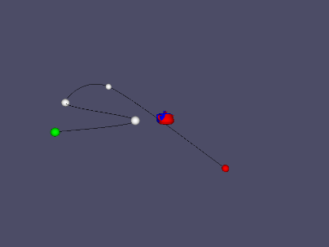

Showing comp

Showing comp zoomed in